Innovative Responses to a Complex World
Edutainment for a Livable Planet Series
THINK LIKE A BATHTUB
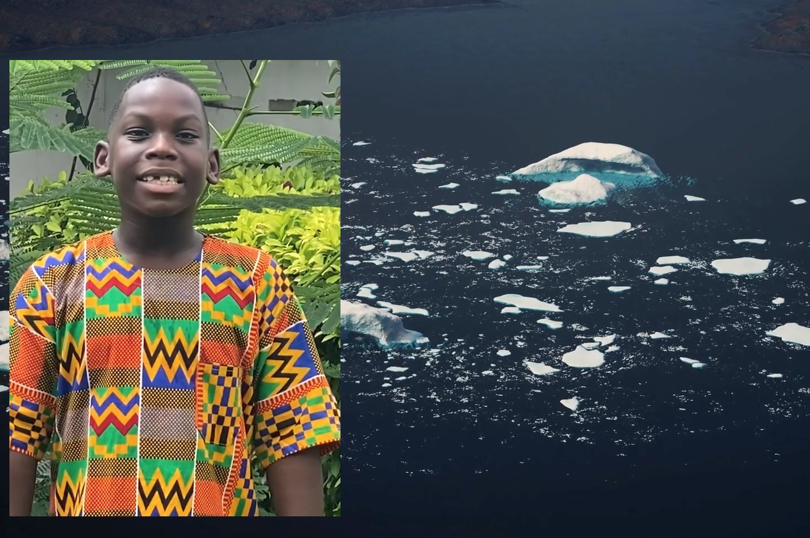
Challenge
Many people want to make a difference when it comes to climate change. But what can one person do? Without a way to make sense of the complexity, it’s easy to feel disempowered and shut down. Other people think the best thing to do is “wait & see”. They assume from climate change can be fixed quickly.

But, if you know how a bathtub works, you know better.

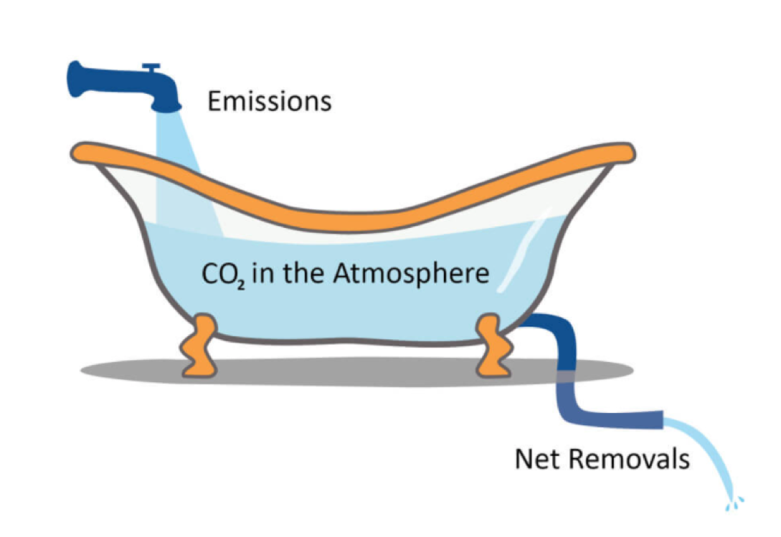
In celebration of the UN Climate Change Conference(#COP26) in Glasgow last month, I was asked to share my early research with Professor John Sterman on the bathtub as easily understand metaphor for climate dynamics. I invited children from around the world to make the case why we all needed to “think like a bathtub”. Working with Emmy-award winning producer Eric Handler, we created this short 3-minute video. In addition, a THINK LIKE A BATHTUB pinterest page is up and we will continue to add related resources for educators, facilitators, activists, parents and others.

We’re thrilled with the impact it’s had so far:
- 997 people have viewed the video via my LinkedIn page
- A engineering professor at Weihenstephan-Triesdorf University (Germany) will be sharing it with students when he introduces systems dynamics.
- A professor at Péter Pázmány Catholic University (Department for Environmental Law and Competition Law) will be sharing it with students and others.
- A professor at Moscow State University will be sharing the video in his urban ecology classes.
- A Massachusetts middle school teacher is tying it into an enrichment class on climate change.
- Multiple direct shares in Glasgow, e.g., by Andrew Jones, co-founder of Climate Interactive.

And, we want to do so much more!
Think Like a Bathtub – The Movement
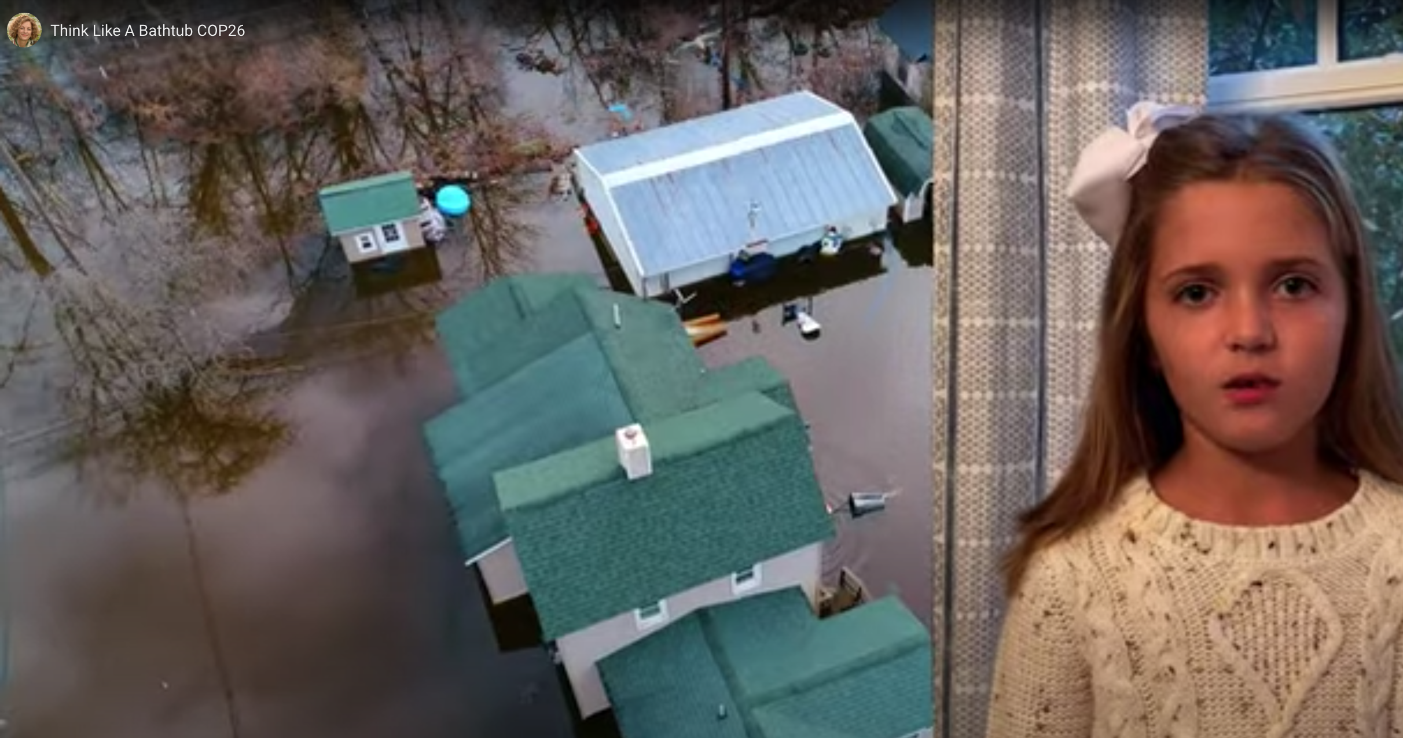
We want to create an age-appropriate edutainment series of books, animated films, videos, games and web content that help kids (and the adults in their lives) to lean into complexity, to see it as a guide rather than the enemy. We also want young people to see how a common metaphor – a bathtub – can give a common focus and mobilize coordinated actions among diverse stakeholders at different levels of scale – in a classroom, community, city, state or country. Think of it as a modern series School House Rocks public service announcements (PSA) for a Livable Planet. The message of this series is simple: You can understand and help solve complex issues related to climate, healthy food systems, racial equity, gender and more. Ultimately you leverage interdependence to innovate together toward healthier futures. The goal is develop edutainment resources for three age bands, ages 4-9, 10-15, 16 and older.

The Science
MIT professor John Sterman originally framed and developed the “carbon bathtub” analog as a way to explain climate change dynamics more broadly. Imagine pouring water into your bathtub twice as fast as it drains out. Even though water is constantly flowing out through the drain, the inflow exceeds the outflow, so the water level in the tub will rise. Eventually, the tub will overflow.
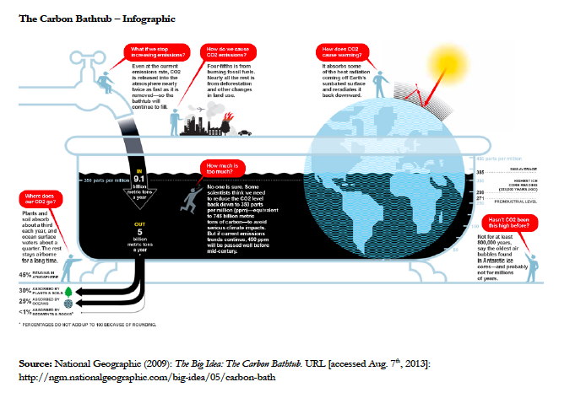
Similarly, humans are putting carbon dioxide into the atmosphere at about twice the rate that natural processes are removing them.
If left unchecked, the tub will soon over flow -- that is, the concentration of greenhouse gases will rise until severe climate change is unavoidable.

I was inspired by the bathtub idea after co-authoring two papers with John: “Bathtub Dynamics” and “Understanding Public Complacency About Climate Change.” In 2005, National Geographic picked the carbon bathtub as a BIG IDEA for that year.
Next Steps:
- Create a youth-focused PSA interstitial/animation to be shown between youth programming on broadcast TV, in-Apps, and streaming services such as Disney+, Netflix, Kodoodle TV, CuriosityStream, etc. We are currently looking for content partners and financial support for development of youth interstitial and related programming for youth and adults.

- Develop three enrichment units for K-2, and middle school and high school.
  - K-2: Complete companion picture book and related enrichment unit for K-2 students.
  - Middle School: Develop enrichment unit using Bathtub Game (from Climate Change Playbook) and THINK LIKE A BATHTUB video.
  - Develop a VR enrichment unit for climate science (grades 9-12) organized around the THINK LIKE A BATHTUB video.
- For current video:
  - Identify distribution partners (e.g. climate action groups such as 350.org, Sunrise Movement, Citizens Climate Lobby, Climate Reality Project, Climate Solutions, ConservAmerica, Outdoor Afro, Earth Justice etc.), nature education centers, sustainability-focused education programs (elementary to university level), TikTok influencers
  - Connect with local, state and national government leaders, encouraging them to co-develop local #ThinkLikeABathtub understandact campaigns. We are currently reaching out to Washington State Governor Inslee’s climate team and working to connect with President Biden’s climate communications/education lead and Secretary of State John F. Kerry, who serves in the Biden administration as a special envoy for climate.

About the Creative Team
Dr. Linda Booth Sweeney is a whole-systems learning pioneer, author and founder of The Toggle Group. Through the Toggle Group, she co-creates experiential learn/do opportunities for people of all ages to see, understand and work with interdependent systems. She develops a variety of book and multi-media resources to enable learners ages 3-103 to lean into complexity including the PBS Learning Media systems literacy pilot, Toggle Labs, and an augmented reality learning app (in development). She is currently leading a series of systems leadership labs for a global foundation. Linda is the author of The Systems Thinking Playbook (co-authored with Dennis Meadows), Connected Wisdom: Living Stories about Living Systems, When a Butterfly Sneezes and the Climate Change Playbook and has a second career as award-winning children’s book author. Her next children’s book, APART TOGETHER, a child’s first book of systems thinking, will be published by Harper Collins (2023).

Eric Handler
Eric is an Emmy Award-winning producer, writer, and director. Eric was one of the co-creators of FETCH! with Ruff Ruffman on PBS. Eric has produced and directed children’s content for America’s Test Kitchen, he’s been a producer for Arthur, Design Squad, Z OOM, Curious George, and the new Ruff Ruffman Show, and has written for Peep and the Big Wide World. He was also a producer on BOSTON: An American Running Story, narrated by Matt Damon. Eric holds a Master’s Degree in Visual and Media Arts from Emerson College.

CONTACT: Dr. Linda Booth Sweeney, linda@lindaboothsweeney.net
+1-978, 369-1557

