A new inspiring educational smartphone APP!

An APP that provides a valuable resource to all teaching staff striving to make a difference in the outdoors!

What is the APP all about?
For years, many of us educators and instructors have shared our ideas and creativity on different ways to better educate and inspire today's society and youth. Our desire was to pool these great resources into one simple resource that helps inspire a dynamic learning environment – both indoors and outdoors. A simple yet purposeful resource at your fingertips that encourages interactive learning and a connection to nature. Introducing the 'Outdoor Ed APPbag of Tricks' APP!
The APP contains a wide range of topics and activities including: Icebreakers, program idea’s, educational and thought provoking readings and activities, quotes, initiatives, solo activities, campfire games, fun games, environmental readings and activities, canoe games, Aboriginal learning's, gear checklists, program debriefs, bushfire safety, inspiring words (from high achievers), unique activities & more!
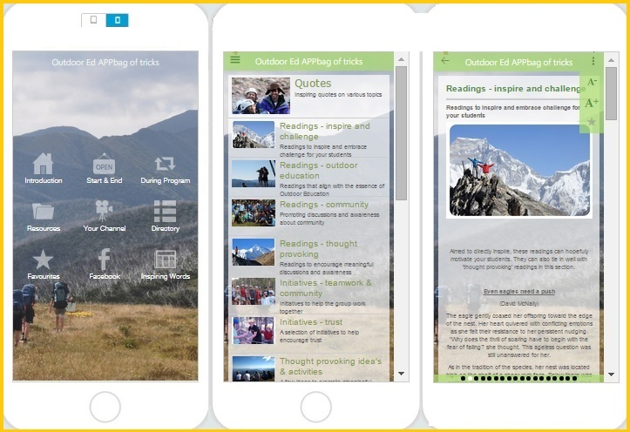
Our desire is to have the APP as a growing resource that all teaching staff can contribute to, be a part of & take ownership of with new versions to follow. For more information or to download the APP ($8.99 Apple & Android), please visit www.wildexposure.com.au & click on the APP page. Thankyou.
email: info@wildexposure.com.au http://www.wildexposure.com.au
NOTE: This APP has been developed by passionate Outdoor staff as a personal venture & is not subsidised and therefore $8.99 just covers the APP store fee’s and hosting costs. Please support us!

