Updated K-12 Resources for North Carolina Educators
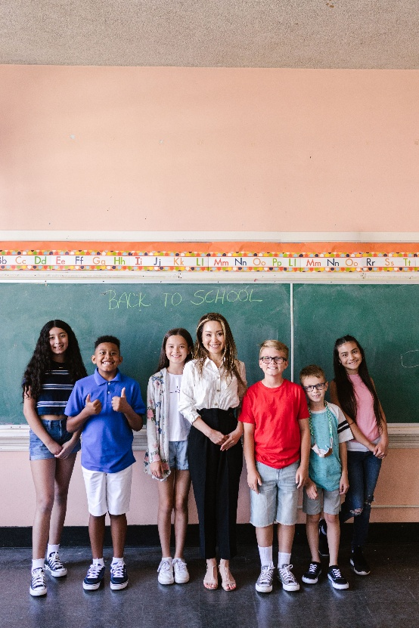
The Clean Classrooms for Carolina Kids™ program is pleased to share new and updated curriculum resources that help students learn about environmental health and lead in drinking water through engaging, classroom-ready lessons. As part of North Carolina’s effort to address lead and asbestos hazards in public schools and licensed child care facilities, the program provides educational resources that support healthy learning environments and increase awareness of environmental health topics.
The refreshed curriculum features free K-12 lessons, activities, and Project-Based Learning Units, organized by grade band and designed for use across disciplines, in social studies, ELA, math, and science. To support multi-cultural learning communities, many resources are available in Spanish.
Educators are invited to explore the updated curriculum and discover ready-to-use resources that can enhance instruction, engage students in real-world learning, and support the lead exposure prevention work that’s been ongoing in North Carolina schools through the Clean Classrooms for Carolina Kids program, and in programs across the country.
Access the curriculum: Clean Classrooms for Carolina Kids Curriculum.
For curriculum or program questions, please contact us here: Contact Us.
Please share this opportunity with educators and school staff across your network.

