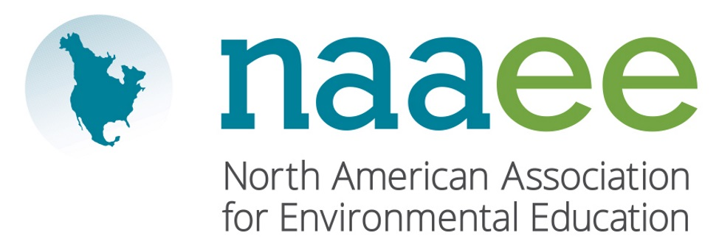

|  |  |  |  |  |  |  |  |  |  |
| --- | --- | --- | --- | --- | --- | --- | --- | --- | --- |
| |  |  | | --- | --- | | Contact | Judy Braus | | Telephone | 202-419-0412 | | Email | info@naaee.org | | Website | www.naaee.org | | FOR IMMEDIATE RELEASEOctober 16, 2017 |

**SUSAN TOTH WINS ENVIRONMENTAL EDUCATION AWARD**

Local educator recognized by North American Environmental Education Association

Stuart, FL, October 16, 2017– Susan Toth, a longtime educator in the field of environmental education, was recently recognized by the North American Association for Environmental Education (NAAEE). Toth received the Walter E. Jeske Award, which is the highest honor NAAEE bestows for contributions in environmental education. It is named after Walter Jeske, former Chief of the Education and Publications unit within the U.S. Soil Conservation Service, who died suddenly in 1981.

Since the 1980s, Toth has held numerous leadership roles in the field of environmental education. As Director of Education at Pine Jog Environmental Education Center, Toth improved and expanded elementary school programs and oversaw the construction of Florida’s first Gold LEED-Certified elementary school. She also developed a Master’s program in environmental education in partnership with Florida Atlantic University. Toth served on the Florida Advisory Council on environmental education, the Florida Greenways Commission, the NAAEE Board of Directors, and is a founding member of the Green School National Network Board. In addition, Toth was a regular environmental education instructor for University of Wisconsin–Stevens and the Smithsonian Institution, and wrote a series of children’s books on water and energy.

“Susan Toth’s accomplishments exemplify environmental education leadership and service at the highest level,” said Judy Braus, NAAEE’s Executive Director. “Our award winners are leading the way toward a more sustainable society from classrooms to communities across North America.”

This year, NAAEE presented 10 awards to outstanding individual and organizational leaders across North America. For a full list of 2017 winners, visit [www.naaee.org/our-work/programs/awards](http://www.naaee.org/our-work/programs/awards).

**About the North American Association for Environmental Education**

For four decades, the North American Association for Environmental Education (NAAEE) has been dedicated to accelerating environmental literacy and civic engagement through the power of education. NAAEE supports a network of 20,000 educators and 56 regional affiliate organizations working in environmental education in more than 30 countries. For more information, visit [www.naaee.org](http://www.naaee.org).

# # #

For more information, contact Judy Braus at 202-419-0412 or email at info@naaee.org.