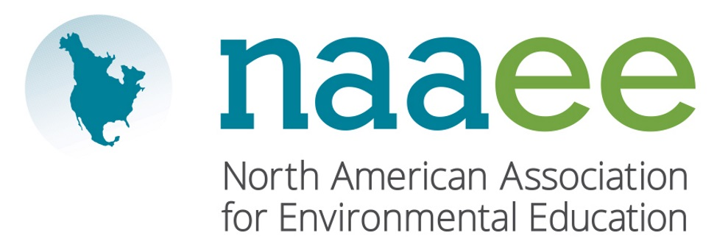
Contact Judy Braus  Telephone 202-419-0412  Email info@naaee.org  Website www.naaee.org | FOR IMMEDIATE RELEASE  October 16, 2017

DR. Jacqueline S. McLaughlin Wins environmental education award

Local educator recognized by North American Environmental Education Association

Center Valley, PA, October 16, 2017– Dr. Jacqueline McLaughlin, Associate Professor of Biology at Penn State University, Lehigh Valley, was recently recognized by the North American Association for Environmental Education (NAAEE). McLaughlin was honored with the Higher Education Educator of the Year Award, given to educators for promoting environmental education and utilizing the environment as a context for learning in their teaching.

In 2004, McLaughlin founded Connecting Humans and Nature through Conservation Experiences (CHANCE), an award-winning, international environmental education program in partnership with the Pennsylvania Department of Education. Boasting support from over forty partners and sponsors around the globe, CHANCE provides virtual and field opportunities for students and educators to conduct research that addresses global environmental concerns. Hundreds of teachers and students have taken part in CHANCE’s field course programs since its inception. Annually, nearly 10,000 students participate in CHANCE’s online research-based activities. Students feel strongly motivated by their participation to engage in environmental stewardship activities outside of the program. The program has contributed to a measurable increase in environmentalism in Costa Rica and China.

“Dr. Jacqueline McLaughlin’s leadership, in and out of the classroom, has made an invaluable contribution to the field of environmental education,” said Judy Braus, NAAEE’s Executive Director. “Our award winners are leading the way toward a more sustainable society from classrooms to communities.”

This year, NAAEE presented 10 awards to outstanding individual and organizational leaders across North America. For a full list of 2017 winners, visit www.naaee.org/our-work/programs/awards.

About the North American Association for Environmental Education

For four decades, the North American Association for Environmental Education (NAAEE) has been dedicated to accelerating environmental literacy and civic engagement through the power of education. NAAEE supports a network of 20,000 educators and 56 regional affiliate organizations working in environmental education in more than 30 countries. For more information, visit www.naaee.org.

# # #
For more information, contact Judy Braus at 202-419-0412 or email at info@naaee.org.

