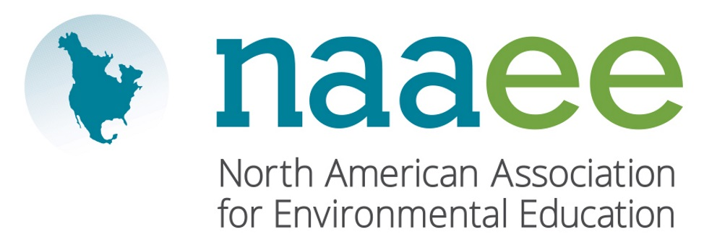
Contact Judy Braus  Telephone 202-419-0412  Email info@naaee.org  Website www.naaee.org | FOR IMMEDIATE RELEASE  October 16, 2017

Constance russell Wins ENVIRONMENTAL education award

Local educator recognized by North American Environmental Education Association

Thunder Bay, ON, October 16, 2017– Dr. Constance Russell, Professor in the Faculty of Education at Lakehead University, was recently recognized by the North American Association for Environmental Education (NAAEE). Russell was honored with the Outstanding Contributions to Research in Environmental Education Award, given to individuals who exemplify national leadership in the field of environmental education research.

Dr. Russell has demonstrated outstanding contributions to research in environmental education through her work on social justice, human-animal relationships, and ecotourism. Dr. Russell's most widely known contribution to the field has been through her editorial work. She played a leadership role as Editor of the Canadian Journal of Environmental Education for 15 years. Russell was co-editor of a special issue of 'Pathways: Ontario Journal of Outdoor Education' and co-edited two special issues of the Journal of Environmental Education. Dr. Russell is on the International Advisory Board of the journal Environmental Education Research. Throughout her career, she has mentored colleagues and maintained the highest standards of research and publishing.

“Dr. Constance Russell exemplifies truly inspirational environmental researchers who change the field,” said Judy Braus, NAAEE’s Executive Director. “Our award winners are leading the way toward a more sustainable society from classrooms to communities across North America,” said Judy Braus, NAAEE’s Executive Director.

NAAEE presented 10 awards to outstanding individual and organizational leaders across North America. For a full list of 2017 winners, visit www.naaee.org/our-work/programs/awards.

About the North American Association for Environmental Education

For four decades, the North American Association for Environmental Education (NAAEE) has been dedicated to accelerating environmental literacy and civic engagement through the power of education. NAAEE supports a network of 20,000 educators and 56 regional affiliate organizations working in environmental education in more than 30 countries. For more information, visit www.naaee.org.

# # #

For more information, contact Judy Braus at 202-419-0412 or email at info@naaee.org.

